Project: Data Analysis and Regression in Excel
EV Electrical Vehicles Dataset

1. Introduction
- Dataset: EV Electrical Vehicles Dataset .
- Source: Kaggle.
- Description of data: This dataset contains electric vehicle specifications with 3,023 rows and 17 columns spanning model years 2015-2025. It includes key metrics like battery capacity, driving range, charging time, price (USD), safety ratings, and sales data. The data covers various manufacturers and models, tracking EV technology evolution and market trends over a decade.
- Domain: Business / Finance
2. Data Cleaning & Preprocessing
STEP 1: Removing Missing Values
The dataset was first checked for missing values using the Excel Filter tool. The drop-down menu was used to select blank entries in each column. Rows containing blank cells were identified and deleted entirely. This process was repeated for all columns to ensure no missing values remained.
STEP 2: Remove Duplicates
The “Remove Duplicates” tool under the Data tab was used to identify and delete duplicate records. All columns were selected to ensure complete row-wise comparison. After executing the tool, any duplicate entries were removed, leaving only unique records in the dataset. After these steps, the dataset was reduced to 1846 rows.
STEP 3: Handle Outliers
Two methods were used to detect outliers in numeric columns:
- Method 1 – Using Boxplot:
A box and whisker plot was created for numeric columns using Insert > Statistic Chart > Box and Whisker. Data points located beyond the whiskers were visually identified as outliers.
- Method 2 – Using Formula:
The following calculations were applied:
  - Q1 = QUARTILE.INC(range, 1)
  - Q3 = QUARTILE.INC(range, 3)
  - IQR = Q3 – Q1
  - Lower Bound = Q1 – 1.5 * IQR
  - Upper Bound = Q3 + 1.5 * IQR
Values below the Lower Bound or above the Upper Bound were flagged as outliers.

3. Descriptive Statistics

• Vehicle ID
i. Mean (1518.17): The average vehicle ID is approximately 1518.
ii. Standard Error (20.26): The precision of the mean estimate is about 20.26.
iii. Median (1498): The middle vehicle ID value is 1498.
iv. Mode (#N/A): There is no repeating vehicle ID value (all are unique).
v. Standard Deviation (870.31): Vehicle IDs are widely dispersed from the mean.
vi. Sample Variance (757437.2): Confirms high variability in vehicle IDs.
vii. Kurtosis (-1.20): The distribution is flatter than a normal distribution.
viii. Skewness (0.0099): The distribution is almost perfectly symmetrical.
ix. Range (3022): Vehicle IDs span from 2 to 3022.

• Year
i. Mean (2019.98): The average year is approximately 2020.
ii. Standard Error (0.07): The mean estimate is highly precise.
iii. Median (2020): The middle year value is 2020.
iv. Mode (2018): The most frequent year is 2018.
v. Standard Deviation (3.12): Years are moderately dispersed around the mean.
vi. Sample Variance (9.76): Confirms moderate variability in years.
vii. Kurtosis (-1.20): The distribution is flatter than a normal distribution.
viii. Skewness (-0.003): The distribution is almost perfectly symmetrical.
ix. Range (10): Years span from 2015 to 2025.

• Battery Capacity kWh
i. Mean (84.26): The average battery capacity is approximately 84.26 kWh.
ii. Standard Error (0.87): The mean estimate has good precision.
iii. Median (83.6): The middle battery capacity value is 83.6 kWh.
iv. Mode (57.5): The most frequent battery capacity is 57.5 kWh.
v. Standard Deviation (37.28): Battery capacities are widely dispersed from the mean.
vi. Sample Variance (1389.51): Confirms high variability in battery capacities.
vii. Kurtosis (-1.18): The distribution is flatter than a normal distribution.
viii. Skewness (0.04): The distribution is almost perfectly symmetrical.
ix. Range (129.9): Battery capacities span from 20.1 kWh to 150 kWh.

• Range km
i. Mean (353.83): The average range is approximately 354 km.
ii. Standard Error (3.40): The mean estimate has reasonable precision.
iii. Median (353): The middle range value is 353 km.
iv. Mode (395): The most frequent range is 395 km.
v. Standard Deviation (145.94): Ranges are widely dispersed from the mean.
vi. Sample Variance (21297.65): Confirms high variability in ranges.
vii. Kurtosis (-1.23): The distribution is flatter than a normal distribution.
viii. Skewness (-0.014): The distribution is almost perfectly symmetrical.
ix. Range (500): Ranges span from 100 km to 600 km.

• Charge Time hr
i. Mean (6.27): The average charge time is approximately 6.27 hours.
ii. Standard Error (0.08): The mean estimate has good precision.
iii. Median (6.3): The middle charge time value is 6.3 hours.
iv. Mode (11.6): The most frequent charge time is 11.6 hours.
v. Standard Deviation (3.36): Charge times are moderately dispersed from the mean.
vi. Sample Variance (11.26): Confirms moderate variability in charge times.
vii. Kurtosis (-1.22): The distribution is flatter than a normal distribution.
viii. Skewness (-0.008): The distribution is almost perfectly symmetrical.
ix. Range (11.5): Charge times span from 0.5 hours to 12 hours.

• Price USD
i. Mean (91671.44): The average vehicle price is approximately $91,671.
ii. Standard Error (808.16): The mean estimate has reasonable precision.
iii. Median (92888.23): The middle price value is $92,888.
iv. Mode (#N/A): There is no repeating price value (all are unique or nearly unique).
v. Standard Deviation (34713.23): Prices are widely dispersed from the mean.
vi. Sample Variance (1.21E+09): Confirms high variability in vehicle prices.
vii. Kurtosis (-1.21): The distribution is flatter than a normal distribution.
viii. Skewness (-0.062): The distribution is very close to symmetrical.
ix. Range (119920.4): Prices span from $30,014 to $149,935.

• Autonomous Level
i. Mean (2.52): The average autonomous level is approximately 2.5.
ii. Standard Error (0.04): The mean estimate has good precision.
iii. Median (3): The middle autonomous level value is 3.
iv. Mode (3): The most frequent autonomous level is 3.
v. Standard Deviation (1.71): Autonomous levels are moderately dispersed from the mean.
vi. Sample Variance (2.91): Confirms moderate variability in autonomous levels.
vii. Kurtosis (-1.26): The distribution is flatter than a normal distribution.
viii. Skewness (-0.016): The distribution is almost perfectly symmetrical.
ix. Range (5): Autonomous levels span from 0 to 5.

• Safety Rating
i. Mean (3.98): The average safety rating is approximately 4.0.
ii. Standard Error (0.02): The mean estimate has excellent precision.
iii. Median (4): The middle safety rating value is 4.
iv. Mode (3): The most frequent safety rating is 3.
v. Standard Deviation (0.82): Safety ratings are moderately dispersed from the mean.
vi. Sample Variance (0.67): Confirms moderate variability in safety ratings.
vii. Kurtosis (-1.51): The distribution is flatter than a normal distribution.
viii. Skewness (0.036): The distribution is almost perfectly symmetrical.
ix. Range (2): Safety ratings span from 3 to 5.

• Units Sold 2024
i. Mean (10126.74): The average units sold in 2024 is approximately 10,127.
ii. Standard Error (134.16): The mean estimate has reasonable precision.
iii. Median (10103): The middle units sold value is 10,103.
iv. Mode (11666): The most frequent units sold value is 11,666.
v. Standard Deviation (5762.70): Units sold are widely dispersed from the mean.
vi. Sample Variance (33208676): Confirms high variability in units sold.
vii. Kurtosis (-1.19): The distribution is flatter than a normal distribution.
viii. Skewness (-0.017): The distribution is almost perfectly symmetrical.
ix. Range (19985): Units sold span from 6 to 19,991.

• Warranty Years
i. Mean (4.00): The average warranty period is exactly 4 years.
ii. Standard Error (0.02): The mean estimate has excellent precision.
iii. Median (4): The middle warranty value is 4 years.
iv. Mode (5): The most frequent warranty period is 5 years.
v. Standard Deviation (0.82): Warranty years are moderately dispersed from the mean.
vi. Sample Variance (0.68): Confirms moderate variability in warranty periods.
vii. Kurtosis (-1.52): The distribution is flatter than a normal distribution.
viii. Skewness (-0.002): The distribution is almost perfectly symmetrical.
ix. Range (2): Warranty periods span from 3 to 5 years.

# Data Visualization
• Vehicle ID

Interpretation:
The highest frequency of 162 occurs in the range (1002, 1252], indicating most vehicle IDs lie within this interval.

Interpretation:
The boxplot shows that vehicle IDs range from 2 to 3022, with a median of 1498 and an interquartile range from 774 to 2271.5, indicating a fairly symmetrical distribution without significant outliers.

Interpretation:
The line chart shows Vehicle ID values increasing steadily and consistently over the sequence, indicating sequential numbering of vehicle records without gaps or irregularities. The smooth linear progression confirms a well-structured dataset with no missing entries in the ID sequence. This pattern reflects organized data collection and consistent record-keeping throughout the dataset.

• Year

Interpretation:
The histogram shows that the frequency of records across years is fairly uniform, ranging mostly between 156 and 177, with a gap in 2023 indicating missing or no data for that period. This suggests consistent data distribution over the years except for 2023.

Interpretation:
The boxplot of vehicle years shows a symmetrical distribution with the median around 2020, an interquartile range from approximately 2018 to 2022, and no outliers.

• Manufacturer

Interpretation:
This highly fragmented Pie Chart displays over 50 numerical values (ranging from to ) associated with various car brands. However, because all the slices are the same size, the chart fails to visually represent the proportions of the data, requiring the reader to individually inspect every number for meaning.

Interpretation:
The bar chart shows the distribution of vehicle brands, with brands like Honda, Mercedes-Benz, and Porsche likely having the tallest bars (highest counts), while brands like BYD, Dacia, and VinFast have shorter bars (lower counts).

• Model

Interpretation:
The pie chart shows the market share distribution of different electric vehicle models, with models like Ariya, 5 E-Tech, and A6 e-tron likely having the largest slices, while Ami and Spacetourer have smaller shares.

Interpretation:
The bar chart shows the distribution of electric vehicle models, with models like Mustang Mach-E, EQS, and Mini Cooper SE likely having the highest frequencies, while models like Battista and Revuelto have lower frequencies.

• Battery Type

Interpretation:
The pie chart shows battery type distribution, with Nickel-manganese-cobalt (8%) being the most common, followed by Nickel-metal hydride (7%), Zinc-air (7%), and Lithium-ion (7%), while other types like Sodium-ion and Aluminum-ion each represent 6% of the market.

Interpretation:
The bar chart shows the distribution of battery types, with Lithium-ion likely having the tallest bar (highest usage), followed by Nickel-cobalt-aluminum and Solid-state, while types like Magnesium-ion and Calcium-ion have shorter bars (lower usage).

• Battery Capacity kWh

Interpretation:
The histogram of battery capacity shows a roughly symmetrical distribution centered around 80-90 kWh, with most vehicles having battery capacities between 60-120 kWh and decreasing frequencies at both lower and higher capacity ranges.

Interpretation:
The boxplot of battery capacity shows a symmetrical distribution with the median around 84 kWh, an interquartile range from approximately 57 kWh to 111 kWh, and no outliers.

• Range km

Interpretation:
The histogram of vehicle range shows a roughly symmetrical distribution centered around 350-400 km, with most vehicles having ranges between 300-450 km and decreasing frequencies at both lower and higher range values.

Interpretation:
The boxplot of vehicle range shows a symmetrical distribution with the median around 354 km, an interquartile range from approximately 250 km to 450 km, and no outliers.

Interpretation:
This Scatter Plot shows the relationship between "Range km" (-axis) and "Charge Time hr" (-axis). The data points are uniformly and randomly scattered across the entire plot area, covering a range of approximately to km and to hours. This visual confirms there is no correlation or relationship between the range of a vehicle (or item) and its required charge time.

• Charging Type

Interpretation:
The pie chart shows the distribution of charging types, with DC Fast Charging (DCFC) and CCS likely having the largest shares, while Level 1 Charging and Inductive Charging have smaller portions of the market.

Interpretation:
This Bar Chart displays "Total" values for various electric vehicle charging and refueling methods. The values range from a low of for Inductive (Wireless) Charging to a high of for Plug-in Hydrogen Refueling. The chart clearly shows the quantitative comparison of these different energy transfer technologies.

• Charge Time hr

Interpretation:
The histogram of charge time shows a roughly symmetrical distribution centered around 6-7 hours, with most vehicles having charge times between 4-9 hours and decreasing frequencies at both shorter and longer charge durations.

Interpretation:
The boxplot of charge time shows a symmetrical distribution with the median at 6.3 hours, an interquartile range from approximately 3.3 to 9.2 hours, and no outliers.

• Price USD

Interpretation:
The histogram of vehicle prices shows a roughly symmetrical distribution centered around $90,000-$100,000, with most vehicles priced between $60,000-$120,000 and decreasing frequencies at both lower and higher price points.

Interpretation:
The boxplot of vehicle prices shows a symmetrical distribution with the median at $92,888, an interquartile range from approximately $62,000 to $122,000, and no outliers.

Interpretation:
the scatter plot indicates that the "Charge Time" of an item or service is completely independent of its "Price," with prices being widely distributed across all measured charge times.

• Color

Interpretation:
the pie chart is an over-complicated display of numerous numerical values for various color categories, with the highest value being 48 and the lowest being 21 .

Interpretation:
This Bar Chart displays the "Total" values for a large variety of color categories. The values for the numerous colors range significantly, with Green having the highest value at 48 and Navy Blue registering the lowest value at 21.

• Country of Manufacture

Interpretation:
The pie chart shows the distribution of electric vehicles by country, with China (62) and Canada (64) having the largest shares, while countries like Finland (34) and Denmark (33) have smaller portions of the market.

Interpretation:
The bar chart shows the distribution of electric vehicles by country, with China and USA likely having the tallest bars (highest counts), while countries like Denmark, Hungary, and Israel have shorter bars (lower counts).

• Autonomous Level

Interpretation:
The histogram of autonomous levels shows a roughly symmetrical distribution centered around level 2.5-3.0, with most vehicles having autonomous levels between 2.0-4.0 and decreasing frequencies at both lower and higher autonomy levels.

Interpretation:
The boxplot of autonomous levels shows a symmetrical distribution with the median at level 3, an interquartile range from approximately level 1 to level 4, and no outliers.

Interpretation:
This Scatter Plot shows the relationship between "Price USD" (-axis) and the discrete "Autonomous Level" (-axis, to ). The data points are spread across the entire price range ( to ) for every level. This indicates there is no discernible correlation; high and low prices are equally observed across all six Autonomous Levels.

• Safety Rating

Interpretation:
the Safety Rating data is heavily clustered into three distinct, non-consecutive ranges, with the largest group of 638 falling in the lowest bin (3, 3.23).

Interpretation:
The boxplot of safety rating shows a symmetrical distribution with the median at 4.0, an interquartile range from approximately 3.5 to 4.5, and no outliers.

Interpretation:
This Scatter Plot shows the relationship between "Safety Rating" (-axis) and "Units Sold 2024" (-axis). The data is clustered into three distinct vertical lines at Safety Ratings of , , and . For each of these three ratings, the "Units Sold" are spread across the entire range from to . This indicates that the Safety Rating is independent of the number of Units Sold in 2024, as all three ratings are associated with the full spectrum of sales volumes.

• Units Sold 2024

Interpretation:
the number of units sold in 2024 is fairly evenly distributed across the mid-ranges, with the most common range being (11206, 12806), and the frequency dropping significantly for sales counts above 19206.

Interpretation:
The boxplot of units sold in 2024 shows a symmetrical distribution with the median at 10,103 units, an interquartile range from approximately 5,121 to 15,085 units, and no outliers.

Interpretation:
This Scatter Plot shows the relationship between "Units Sold 2024" (-axis) and "Warranty Years" (-axis). The data is confined to three distinct, horizontal lines at , , and years. For each of these warranty periods, the "Units Sold" are broadly distributed across the full range from to over . This indicates there is no correlation between the number of units sold and the warranty duration; products with 3, 4, or 5 years of warranty have achieved the same wide spectrum of sales volumes.

• Warranty Years

Interpretation:
The histogram of warranty years shows a roughly uniform distribution, with relatively equal frequencies across all warranty periods from 3 to 5 years, with slight peaks around 4-4.5 years.

Interpretation:
The boxplot of warranty years shows a symmetrical distribution with the median at 4 years, an interquartile range from approximately 3.5 to 4.5 years, and no outliers.

Interpretation:
This Scatter Plot compares "Warranty Years" () against "Battery Capacity kWh" ( to kWh). The data is spread across the full range of battery capacities for all three warranty periods. This visually confirms there is no correlation between a product's battery capacity and its warranty length.

# 3D plot

Interpretation:
The 3D scatter plot shows the relationship between price and units sold in 2024, indicating that lower-priced vehicles tend to have higher sales volumes, while higher-priced vehicles have lower sales numbers.

Interpretation:
The 3D scatter plot shows that vehicle price generally increases with larger battery capacity, but the relationship is not strictly linear. There is significant price variation for similar battery sizes, indicating that additional factors beyond battery capacity influence electric vehicle pricing.

# Heatmap

Interpretation:
The heatmap shows correlations between vehicle metrics, with the strongest positive relationships likely between Battery Capacity-Range and Price-Autonomous Level, while CO2 Emissions shows negative correlations with other factors.

4. Regression Analysis

• Correlation
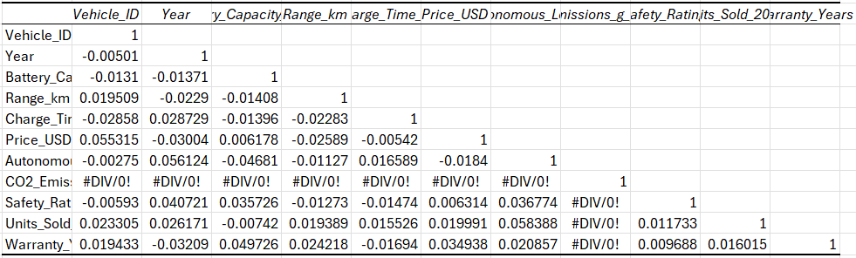
Interpretation:
The correlation matrix shows mostly weak relationships between vehicle metrics. The strongest positive correlation exists between Autonomous Level and Units Sold (0.058), while Battery Capacity and Range show virtually no correlation (-0.014). Most correlations are close to zero, indicating limited linear relationships between these variables.

• Simple Linear Regression
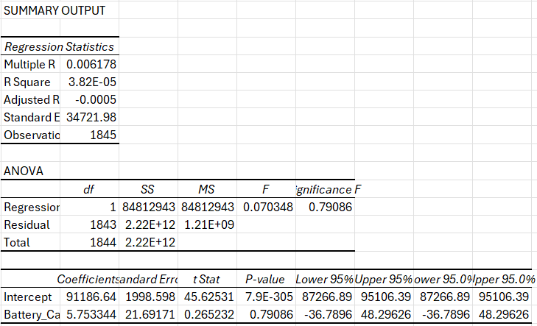
Interpretation:
The simple linear regression analysis reveals that battery capacity is not a statistically significant predictor of vehicle price, with a high p-value of 0.79. The model has an extremely low R-squared value of 0.000038, meaning it explains virtually none of the variation in vehicle prices. The coefficient for battery capacity is 5.75, but with such high uncertainty that the true relationship could be either positive or negative. This indicates that battery capacity alone does not meaningfully influence vehicle pricing in this dataset.

• Multiple Linear Regression
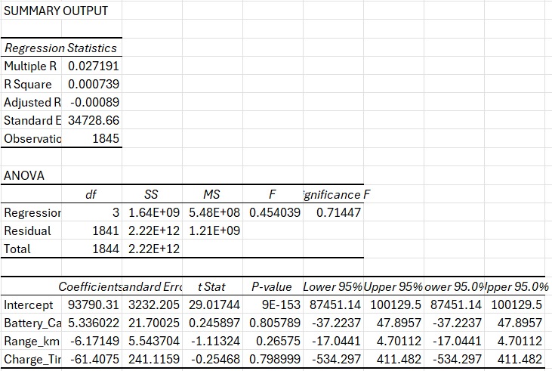
Interpretation:
The multiple regression analysis shows that battery capacity, range, and charge time together are not significant predictors of vehicle price, with an overall model p-value of 0.71 indicating statistical insignificance. The model explains only 0.07% of the price variation (R-squared = 0.000739), which is virtually none. None of the individual predictors are statistically significant - battery capacity has a p-value of 0.81, range has a p-value of 0.27, and charge time has a p-value of 0.80. All coefficients have wide confidence intervals that include zero, confirming the lack of meaningful relationships. Adding range and charge time to the model provides no improvement over using battery capacity alone.

• Plotting Regression Line

Interpretation:
The scatter plot with regression line shows no clear relationship between battery capacity and vehicle price. The nearly flat regression line confirms the weak correlation, with data points scattered widely across all price ranges regardless of battery size. This visualization supports the regression results showing battery capacity does not predict vehicle pricing.

Conclusion:
The analysis reveals that technical specifications like battery capacity, range, and charging time have no significant impact on electric vehicle pricing, as shown by statistically insignificant regression results with near-zero R-squared values. This suggests that factors such as brand value, features, and market positioning play a more crucial role in determining EV prices. The project successfully demonstrated data cleaning, visualization, and regression modeling techniques in Excel, providing a foundation for more advanced pricing analysis.

